**CAR EVALUATION**

**1.INTRODUCTION:**

The objective was to implement naïve Bayes model and predict the results by cross validation method. There are total 10 attributes in car evaluation dataset. The Dataset is shown below

FIGURE1: DATASET

**2.DATA PRE-PROCESSING:**

The data for car_evaluation requires pre-processed data for implementation of Naïve Bayes model. The Python modules and libraries are required for Pre-processing. I will use feature scaling for scale the features and separate the label form the data.

FIGURE2:PRE-PROCESSING

**3.K-FOLD VALIDATION**

The K-folds requires cross validation for data splitting and validation.

FIGURE3:K-FOLD VALIDATION

WEKA RESULTS FOR NAÏVE BAYES

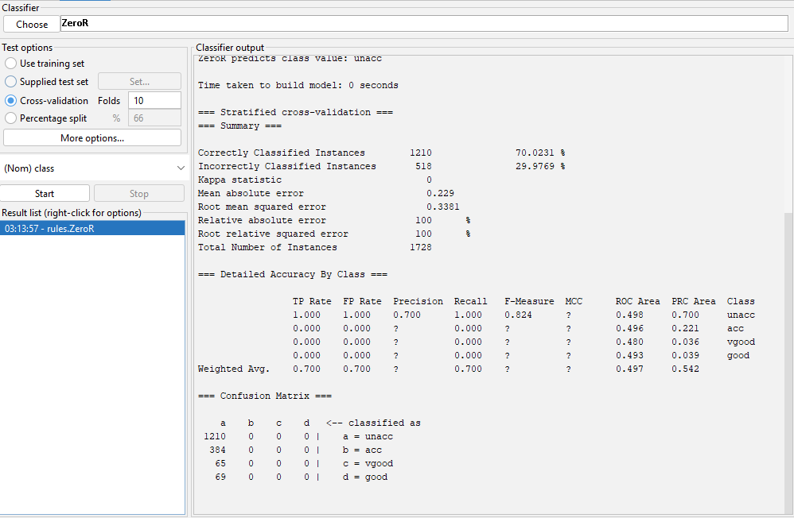

FIGURE 4:WEKA RESULTS

**Comparison of Results**

|  |  |  |
| --- | --- | --- |
| **Naïve Bayes** | **Python** | **WEKA** |
| **Mean absolute error** | 0.714 | 0.22 |
| **Root mean squared error** | 0.8455 | 0.33 |

**4.CONCLUSION:**

The results are compared between python and WEKA tool for cross validation to compute absolute mean error and root mean squared error. The root mean squared for python is 0.8455 and WEKA is 0.22 and absolute mean error for Python is 0.714 and WEKA is 0.33.